# Animal Reports Team C

Eric Gaudreau (2024) ([gaudreae@bu.edu](mailto:gaudreae@bu.edu)), Raghu Nema (2024) ([rnema@bu.edu](mailto:rnema@bu.edu)), Mariano Amaya (2024) ([mariano@bu.edu](mailto:mariano@bu.edu)), Sam Dvorin (2024) ([dvorins@bu.edu](mailto:dvorins@bu.edu)), Shangyuan Chen (2025) ([sychen@bu.edu](mailto:sychen@bu.edu))

Introduction…………………………….2

Base Analysis………………….……….4

Extension Analysis………….………...11

Future Scope…………………………..17

Individual Contribution………………..19

Works Cited……………………………21

## Introduction

The city of Boston seeks a comprehensive understanding of the nature and distribution of animal-related complaints reported by its residents. This report utilizes data collected through the city's 311 reporting system to provide an in-depth analysis of animal complaints, encompassing their frequency, types, locations, and potential influencing factors such as seasonality and weather. The insights gleaned from this analysis will assist the city in optimizing resource allocation, developing targeted interventions, and enhancing its responsiveness to animal-related concerns.  
 The primary data source for this report is the Boston 311 app, a platform designed to facilitate communication between residents and city services for reporting non-emergency issues. The app's user-friendly interface and GPS location tracking capabilities enable residents to conveniently report concerns and provide precise location data. The data source was represented as a CSV from the Analyze Boston website. For this specific analysis, we concentrate on a subset of features within the broader 311 dataset, specifically those pertaining to the type of animal complaint, the geographic coordinates of the incident, and the timestamps for report initiation and closure.  
 This analysis aims to address several key inquiries regarding animal complaints in Boston. First, we investigate trends in complaint frequency over the past 2-3 years and 5-10 years to identify any notable increases, decreases, or periods of stability in reported incidents. Second, we explore the potential influence of seasonal variations on the nature and frequency of complaints, examining whether certain types of incidents exhibit seasonality. Third, we analyze the geographic distribution of complaints to pinpoint areas within the city that may experience a higher concentration of animal-related issues. Finally, we delve into the types of animals most frequently involved in the complaints and explore potential correlations between animal type and the location or nature of the incident.

To extract meaningful insights from the data, we will employ a variety of analytical methods. Time series analysis will enable us to visualize and interpret trends in complaint frequency over time and identify any seasonal patterns that may exist. Spatial analysis techniques will be utilized to map the geographic distribution of complaints and detect potential hotspots within the city. Additionally, we will conduct a frequency analysis to determine the most common types of animal complaints and the species most often involved.

## Base Analysis

**Early Insights Report**

In the early insights report, we attempted to answer the questions: How many reports were there in the previous 5-10 years? Are there any positive or negative trends in these reports? How do other factors such as season impact the nature of the complaints? 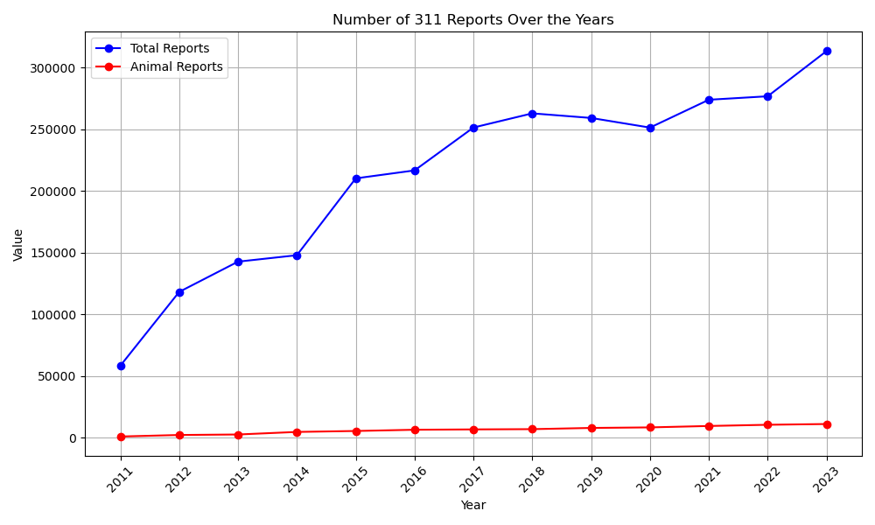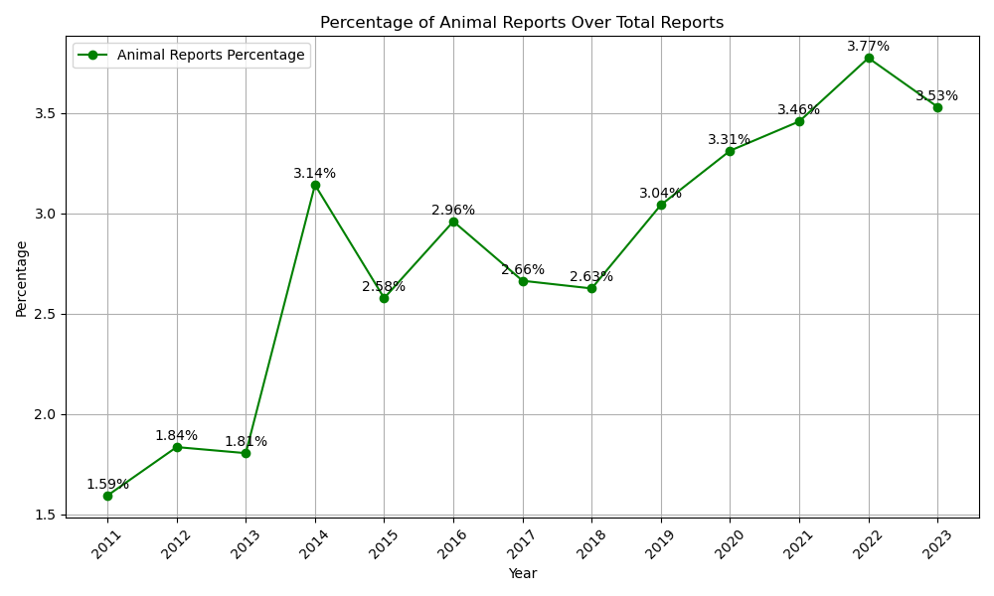

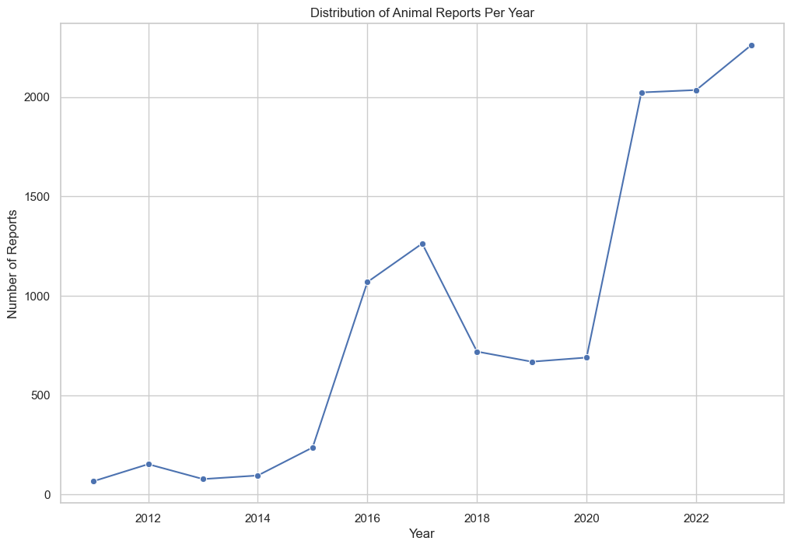

We have observed a steady increase in the number of animal-related complaints over the years, suggesting a growing awareness or ease of reporting through the 311 system. This trend is particularly noteworthy when compared to the overall volume of 311 reports, indicating a rising proportion of animal-related concerns among the issues reported by residents.

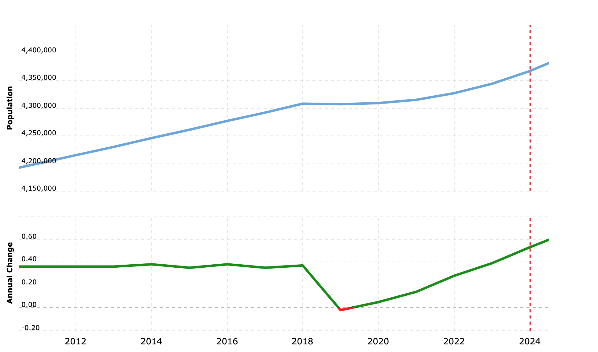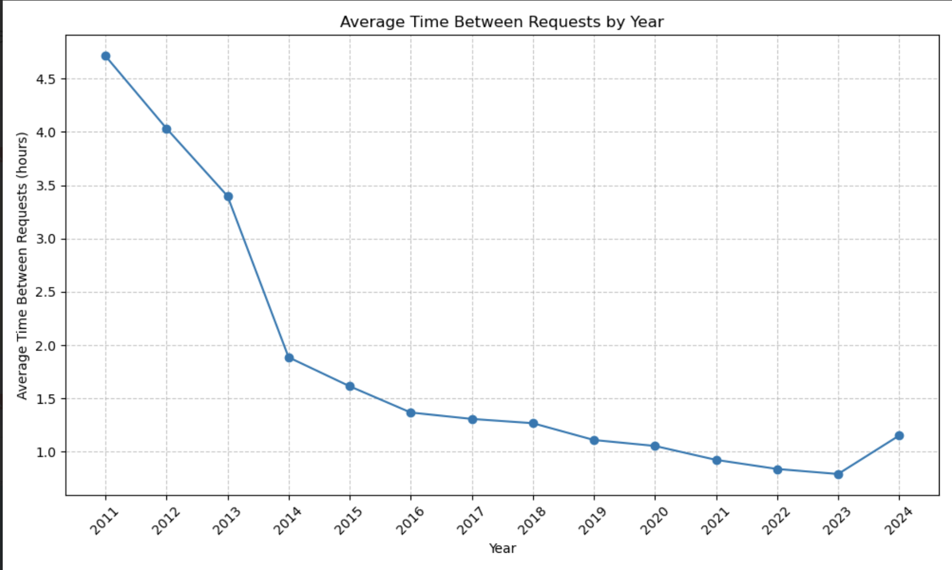

We received Boston population data from MacroTrends, which utilizes United Nations - World Population Prospects as their data source. While Boston's population has also experienced growth, the analysis suggests that this factor alone does not fully explain the increase in animal complaints. Increased awareness and reporting likely play a significant role. Furthermore, the average time between animal-related reports has decreased over the years, hinting at potential improvements in the efficiency of the reporting and response systems.

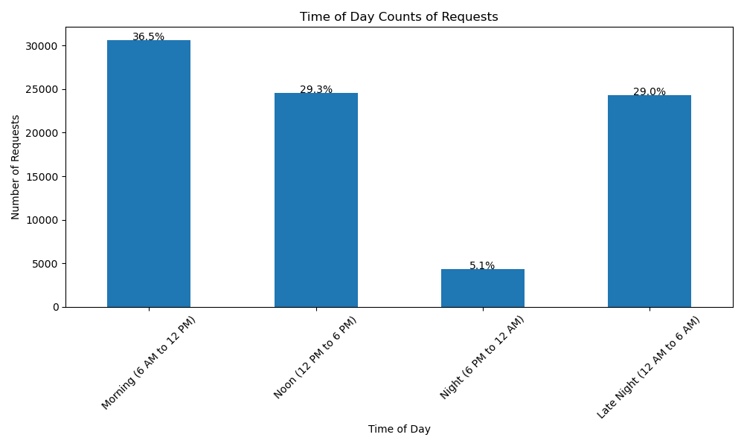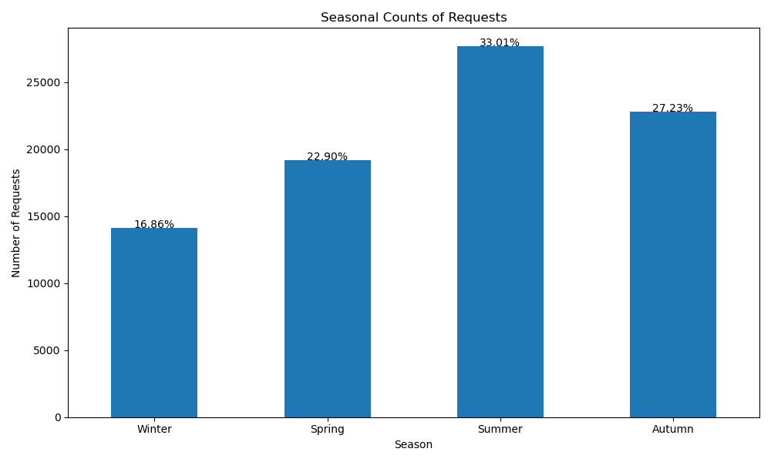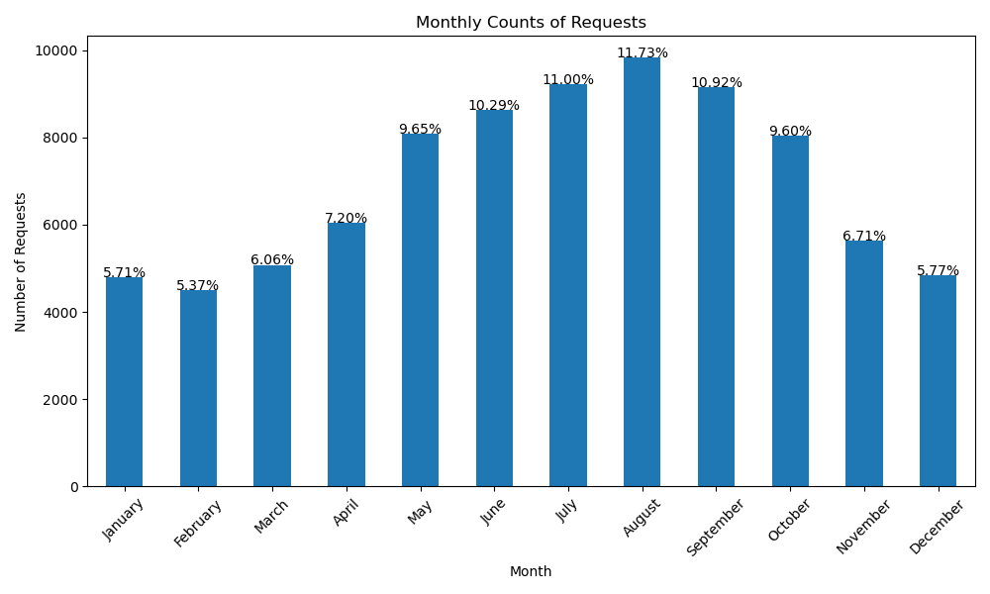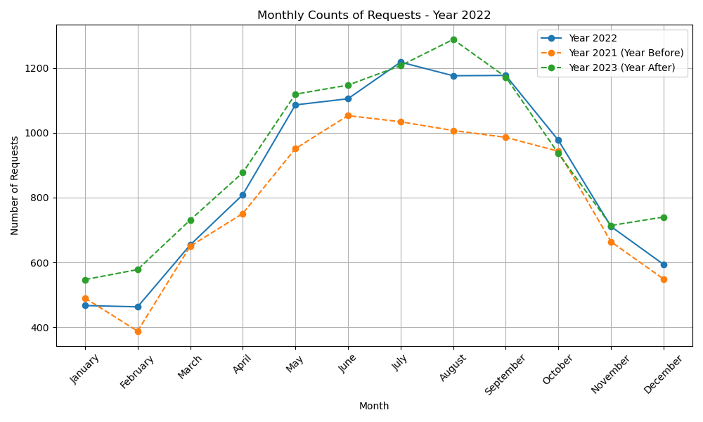

Animal complaints exhibit a clear seasonal pattern, with a peak observed during the summer months. This trend may be attributed to increased human outdoor activity, longer daylight hours, and heightened animal behaviors, such as breeding or foraging, leading to more frequent encounters. A deeper dive into monthly trends reveals a significant decrease in complaints from July to December, likely due to people staying inside due to colder weather and generally reduced animal activity. The data from 2022 shows a notable increase in the number of reports compared to 2021, possibly suggesting the impact of public awareness campaigns or other influencing factors. The majority of animal complaints are received in the morning and late evening, with minimal reports occurring during nighttime hours, aligning with typical human activity patterns and the nocturnal behavior of certain animal species.

**Mid-Semester Report**

In the mid-semester report, we attempted to answer the questions: Where are the complaints coming from geographically? Is there any trend to type of animal complaint and area? What kinds of animals are most common in complaints? Looking into the data, we created many graphs to attempt to answer these questions.

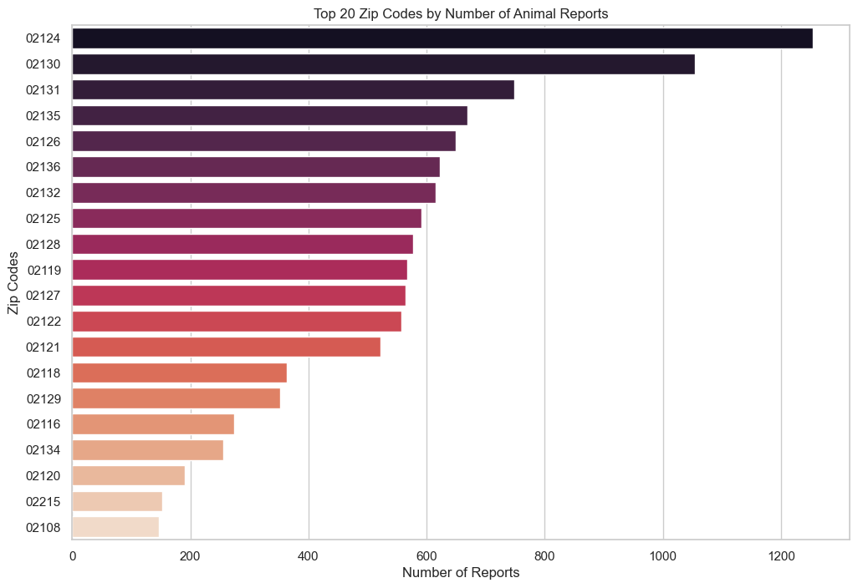

Analysis of the geographic distribution of complaints reveals significant variation across different zip codes. Zip codes 02124 (Dorchester Center) and 02130 (Jamaica Plain) have the highest number of reports, potentially influenced by factors such as population density, proximity to green spaces, and pet ownership rates. Dorchester has a population: 47,783 with a population density of 15,913 people per sq mi. Jamaica Plain has a population of 35,401 with a density of 10,618.

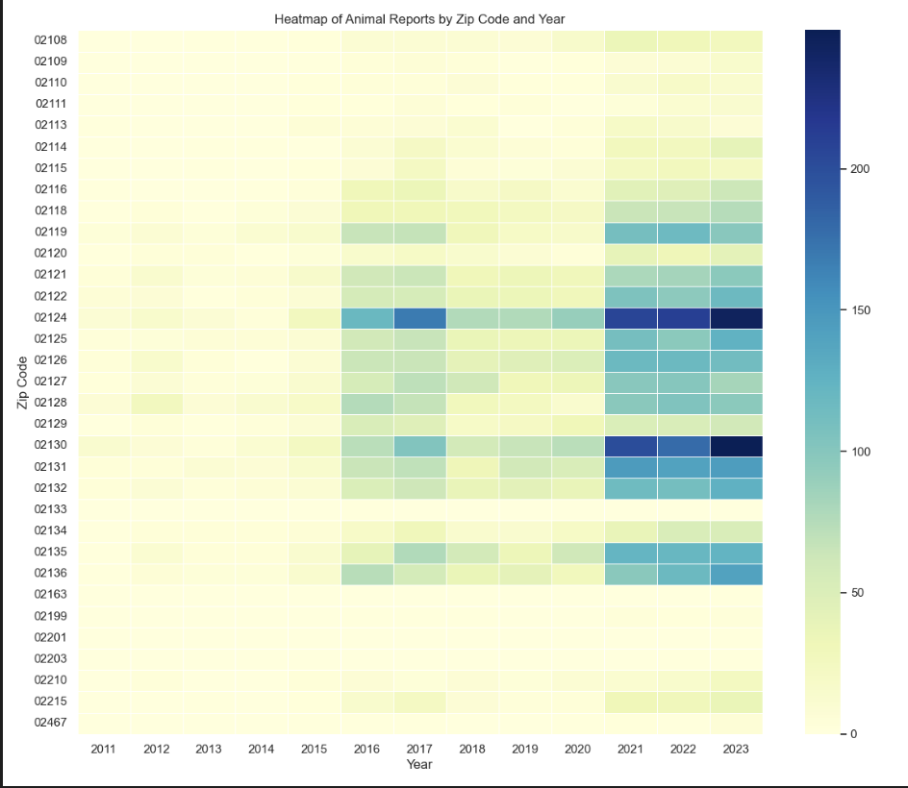

Yearly heatmaps of animal complaints demonstrate evolving patterns in the geographic distribution of reports, with recent years exhibiting a concentration of reports in specific areas compared to the more even spread observed in earlier years. There seems to be specific zip codes that have an increase in reports during 2016 and 2017.

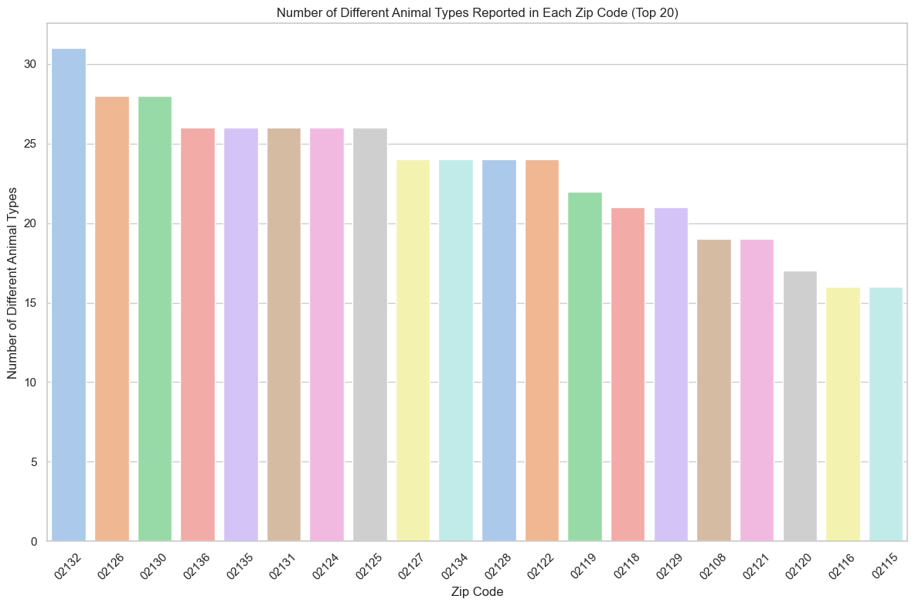

Analysis of the number of unique animal types reported in each zip code suggests a relatively even distribution of animal diversity across the city, indicating that various animal species are encountered throughout different neighborhoods, but most animal types are shared among all the zip codes.

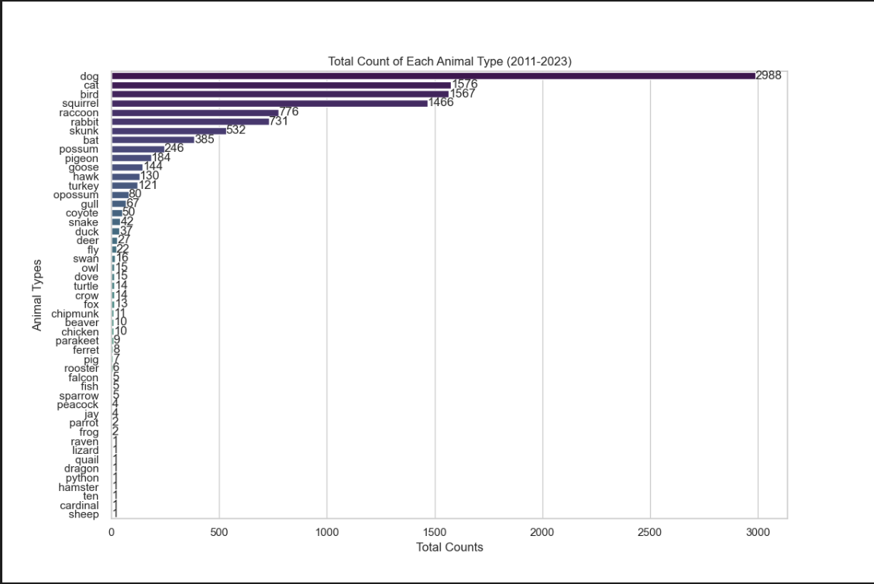

The bar graph shows that most of the reports come from the top 4 animals (Dog, Cat, Bird, Squirrel), suggesting that a significant portion of reports likely involve domestic animals or common urban wildlife. Other animals are rare instances that could be considered special cases and some may be false reporting, such as one report of a sheep or dragon. A significant amount of dog and cat reports could be pets, however, we don’t know if incidents of animals such as cats or birds are for pets or strays, probably a mix of both.

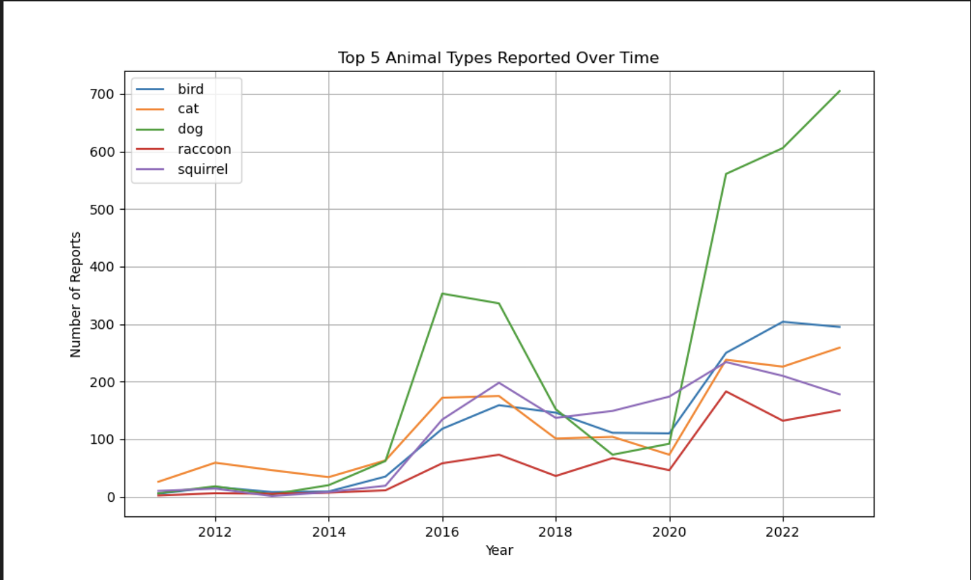

While all animal complaint categories have experienced an increase over time, dog-related reports show a particularly steep rise, especially after 2020. This trend may be linked to an increase in dog ownership or changes in pet adoption patterns during the pandemic. People may also be more likely to report any concerns they may have for their dogs than other animals.



Additionally, for the mid-semester report, we created a gif that allows visualization of the density of animal reports for each month for each year. It was helpful to see the consistent blooming pattern of the heat map due to the rise in reports during the summer season. However, the client found that the data was not detailed enough, so for the final report, we began investigating ways to be more specific in the visualization of the location of reports, so the client would be able to know which areas of each zip code to focus on. Additional heat maps corresponding to all years are available in the data repository.

## Extension Analysis

The extension project encompasses an investigation into the impact of demographic variables (population density) within each zip code on the frequency of animal-related reports. Additionally, spatial analysis techniques were employed to identify potential clusters of complaints within zip codes, aimed to pinpoint hotspots or areas with concentrated reporting activity. Furthermore, the influence of weather events on animal complaint trends was explored, considering the potential impact of hurricanes, and winter storms on the number of requests. To complement these analyses, the project extension also delves into the number of types of different animal requests (Pick up dead animals, etc), and unresolved open cases, as well as examines trends in the number of late case closures across different years.

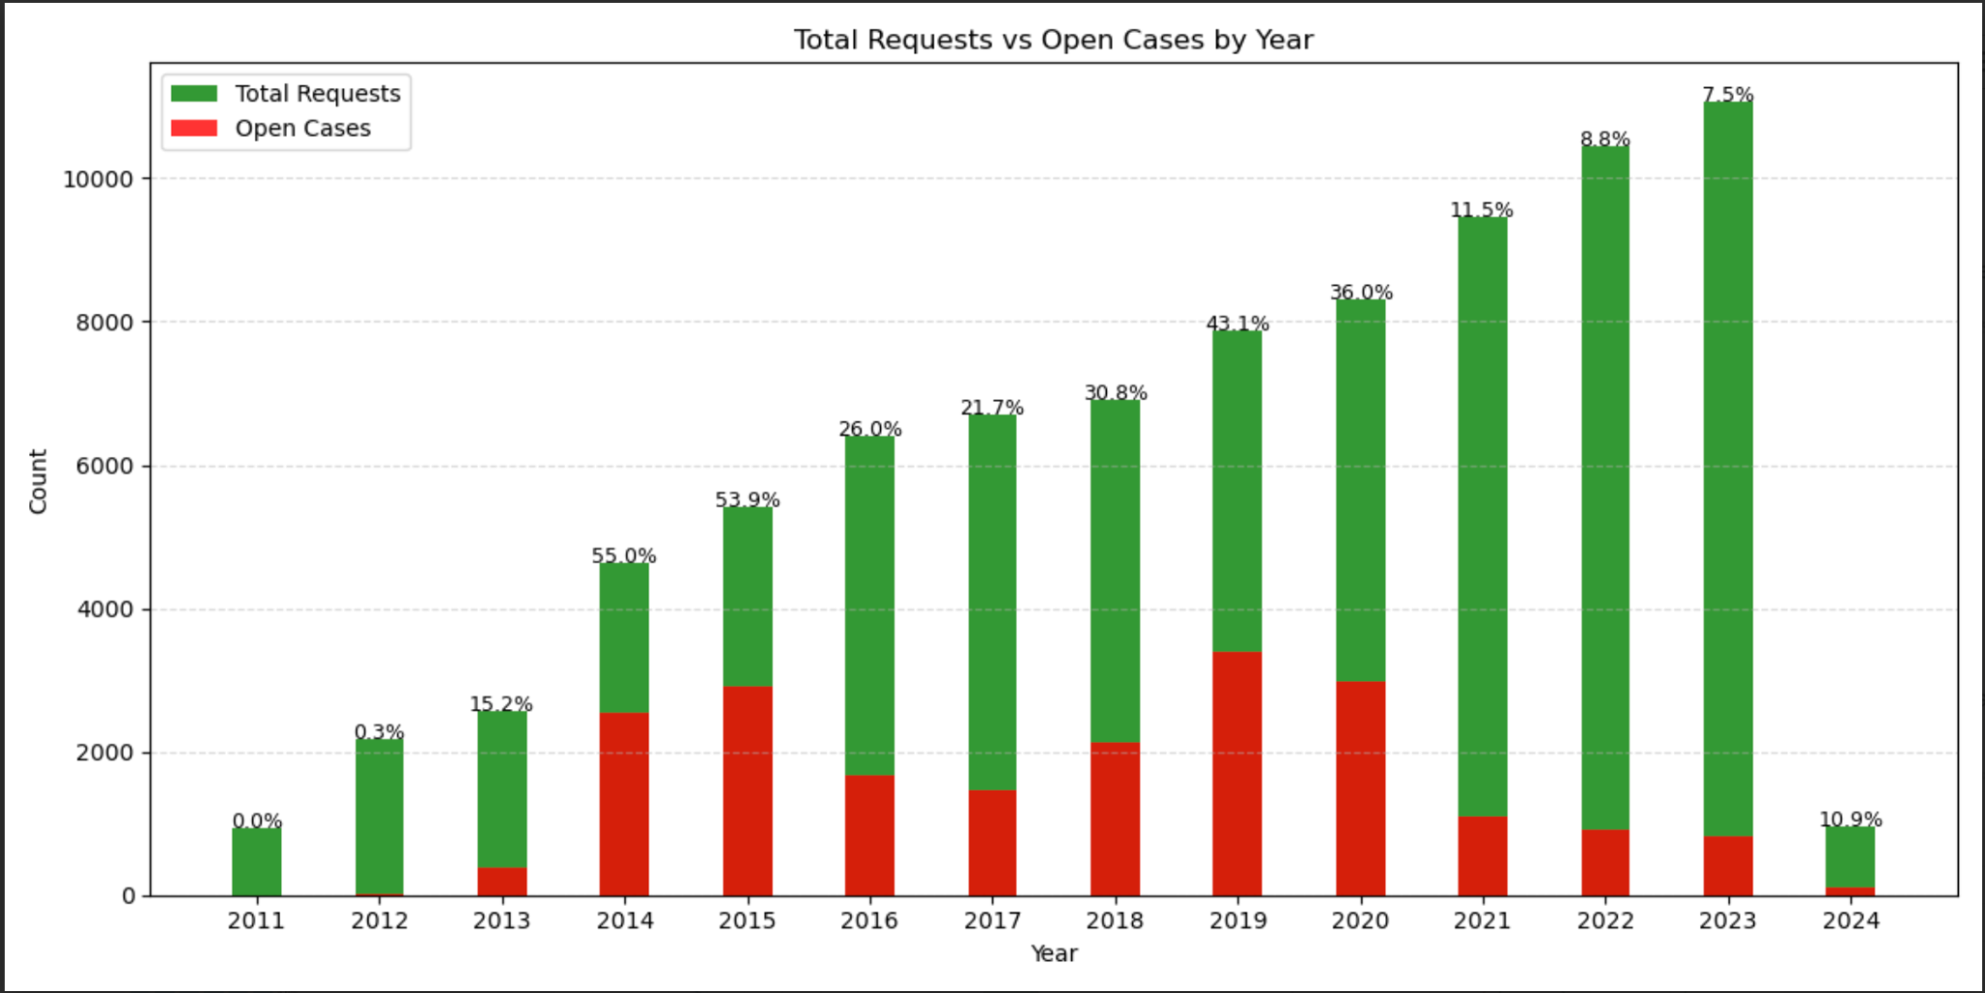

The data includes features tracking the status and timeliness of animal complaint cases. "Case_status" indicates whether a case is "Closed" with a recorded closure date or remains "Open" with no closure date documented. There was a significant decrease in the ratio of open cases to total cases over time. While earlier years saw a higher proportion of open cases, with approximately 50% remaining unresolved in 2014 and 2015, recent years demonstrated a marked improvement in case follow-up and closure procedures.

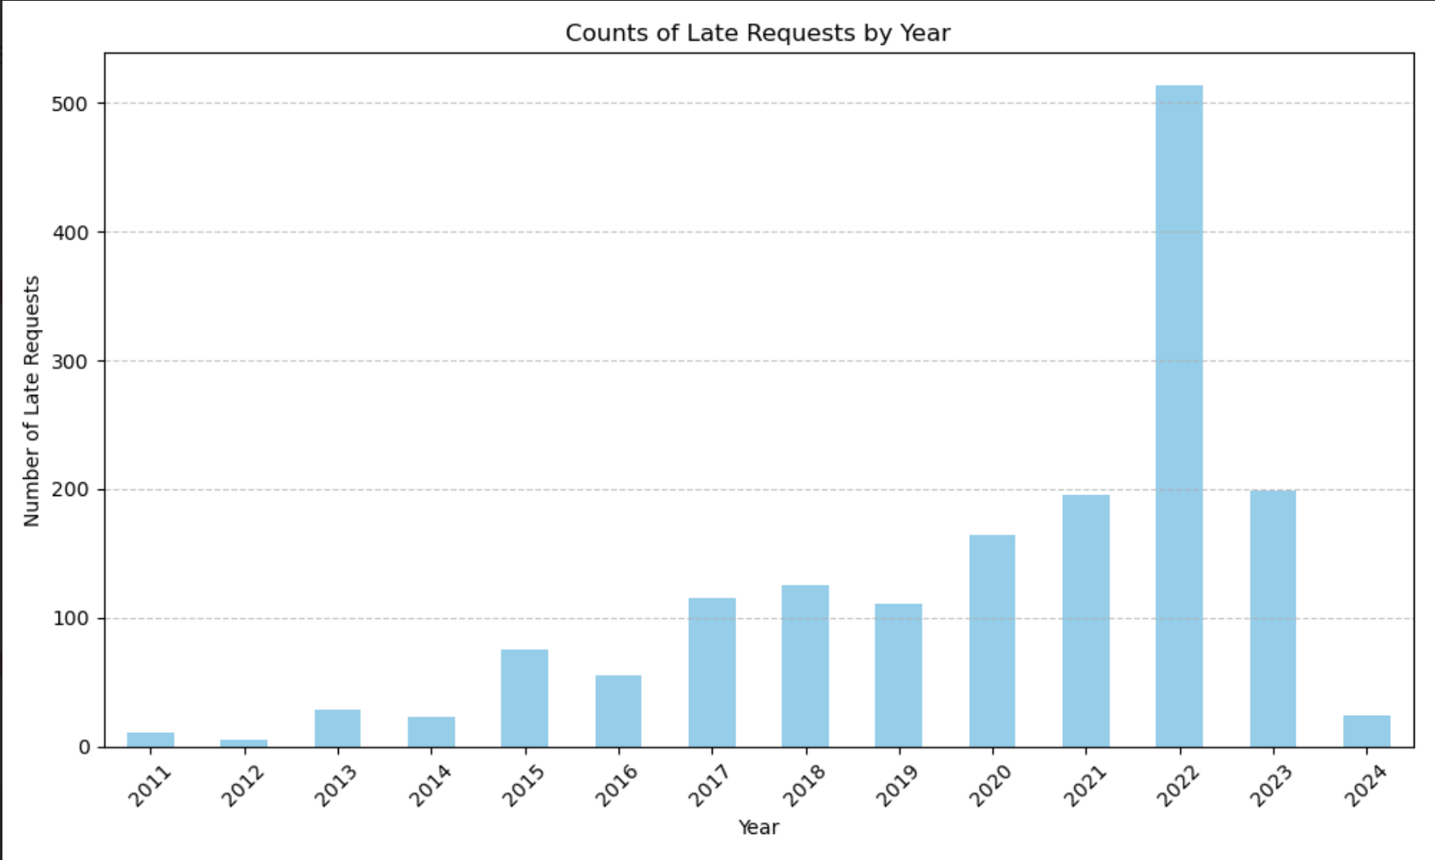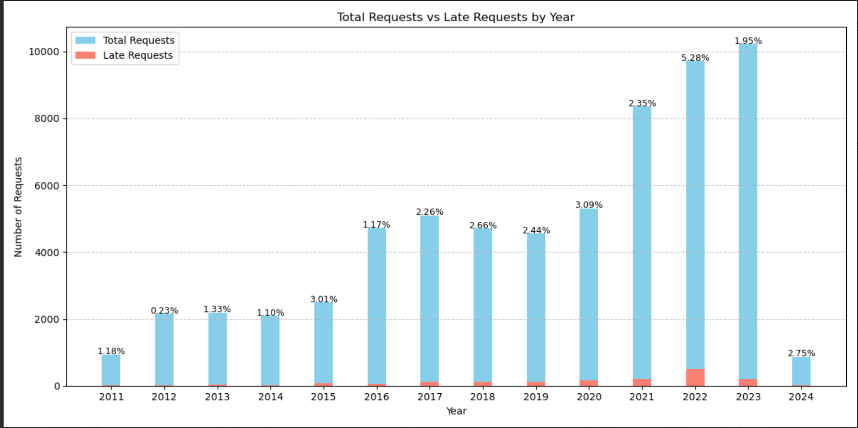

The "On_time" feature assesses the timeliness of case closure, categorizing cases as either "Overdue/Late" if the closure date exceeds the target date or "On time" if the closure occurs before the target date. This provides insights into the efficiency of response and resolution processes for animal-related complaints. Further examination of case timeliness identified a relatively stable trend in the proportion of late closures across most years, except for 2022 which exhibited a notable increase in cases closed after the designated target date. This anomaly suggests potential challenges or delays within the case management system during that specific period.

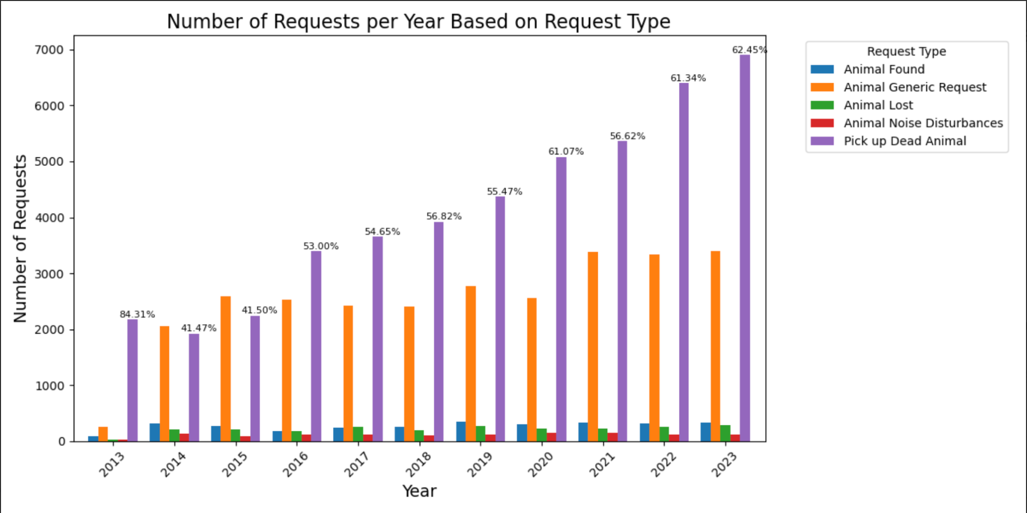

Looking specifically into the type of animal requests, we found that there's been an increase in “Pick up Dead Animal” requests. In 2023, 62% of all animal requests were labeled as “Pick up Dead Animal”. Perhaps there was a more proactive approach in managing deceased wildlife in public spaces that is causing an uptick in reporting or perhaps there are simply more dead animals to pick up in recent years.

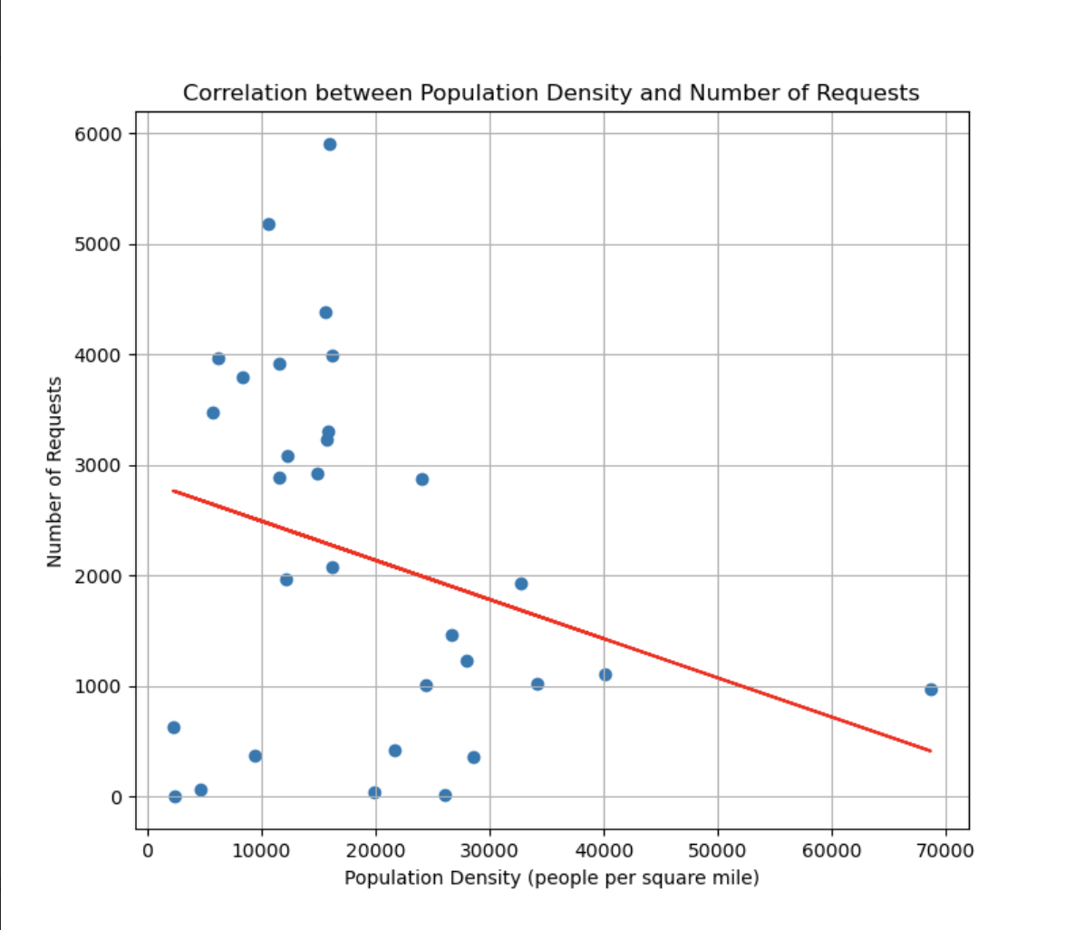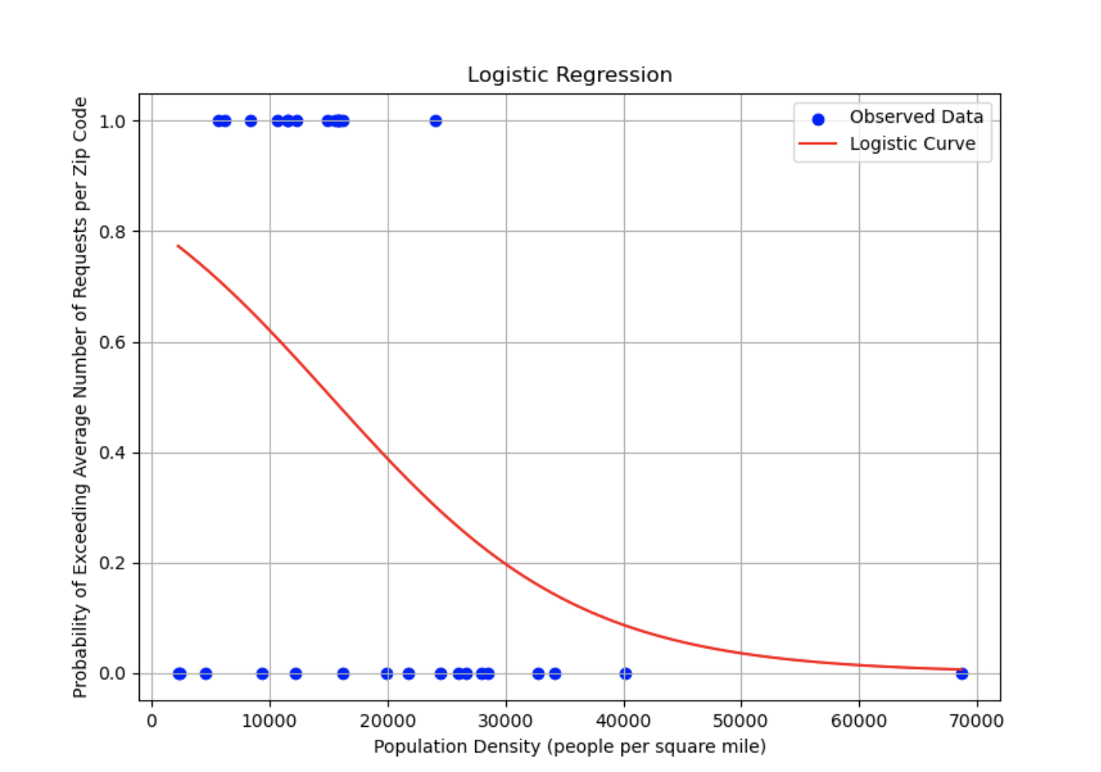

Looking into the relationship between population density and number of requests, this trend does not appear to be strictly linear. Population density data for each zip code came from the United States Zip Codes website. We found that zip codes with very low population density tend to exhibit fewer animal-related reports. However, zip codes with medium population density demonstrate a higher number of animal complaints, indicating a potential peak in reporting within a certain range of population density. Interestingly, as population density increases further, the number of animal complaints tends to decrease again. One possible explanation is that as population density decreases, there are fewer humans to report requests. As population density increases there are more humans to report requests and more animals take up the space not used by humans, but as population density increases even further, humans start taking up a lot of space than animals, and therefore, there are fewer animals to report.

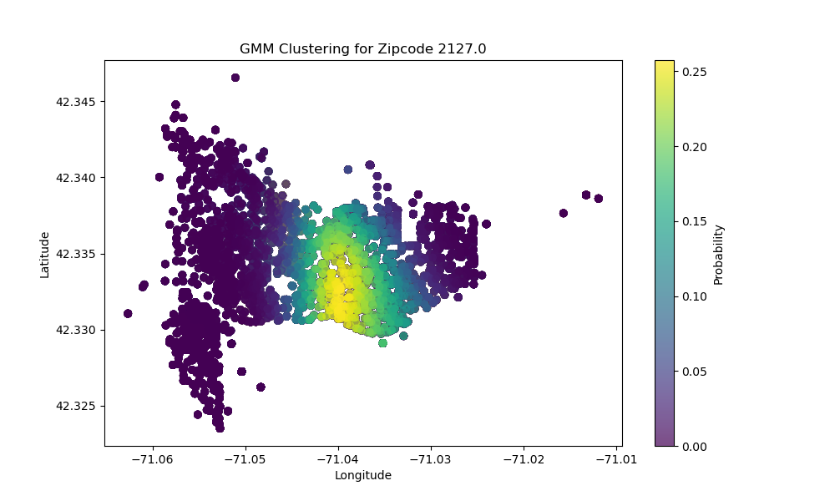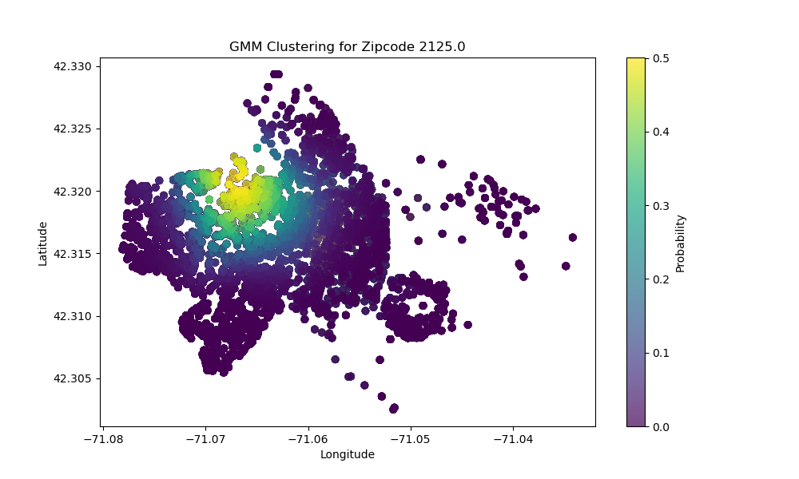

Using a Gaussian Mixture Model, we found “hot spots” for each zip code, which shows the relative density of reports. Each hotspot has varying degrees of spread, meaning in some zip codes the reports are more widespread, and in other zip codes reports are more centered around one area. We believe this information can be useful in identifying where resources should go to deal with animal reports, as the data suggests that some places have a much more concentrated likelihood of animal problems. All density based zip codes figures can be found in the project repository.

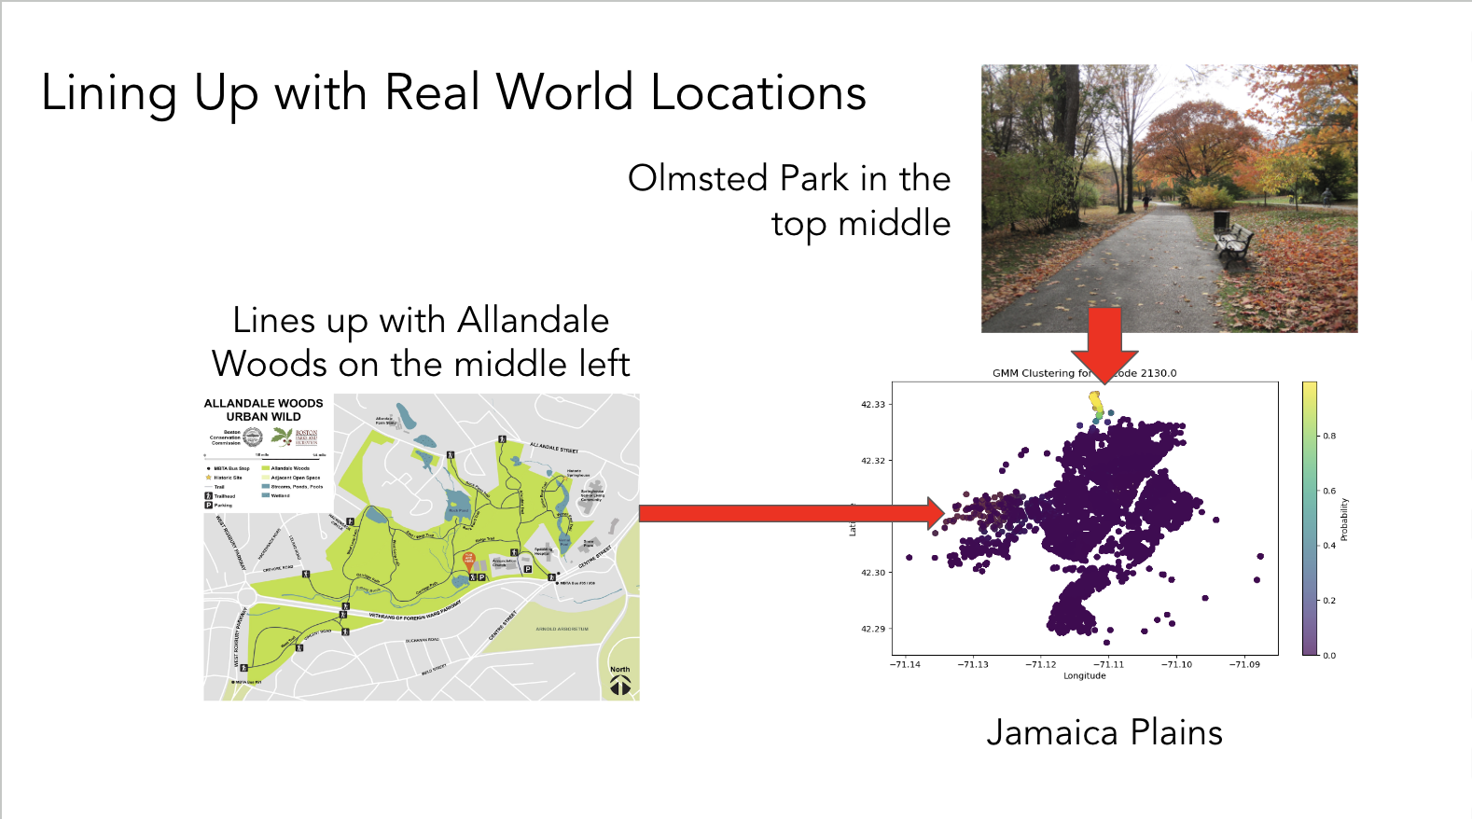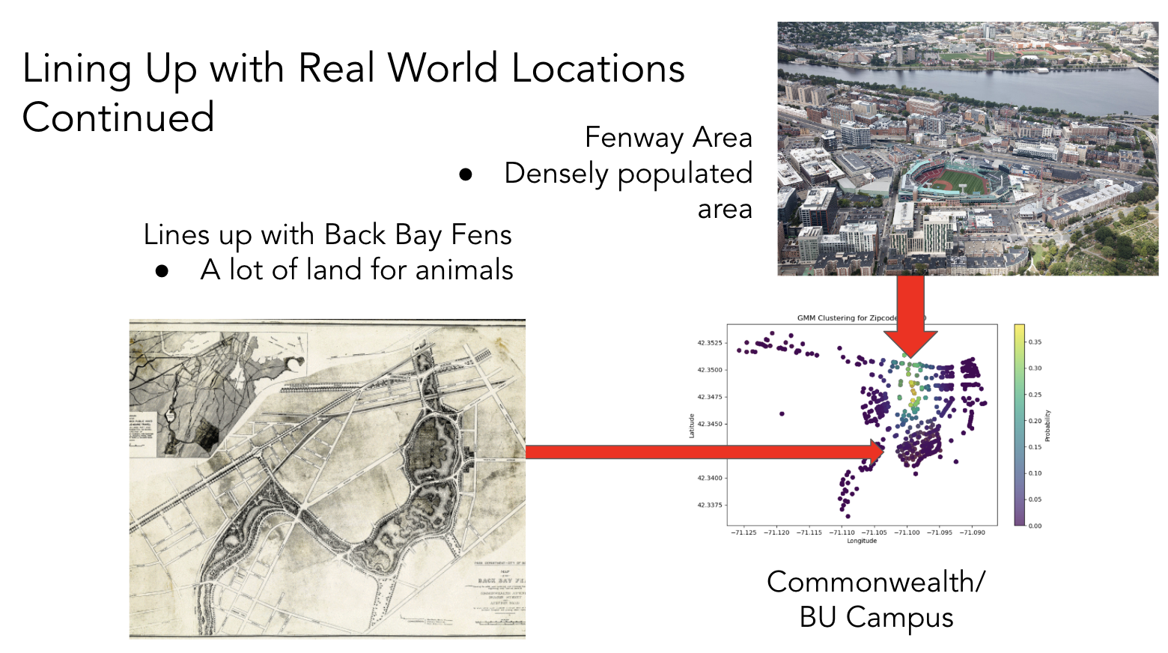

We lined up real-world locations for some of the zip code hotspots found. Most hotspots are related to densely populated areas, such as Fenway, or areas consisting of a lot of nature, such as the woods or parks. This makes sense as there are many people to report animals in densely packed areas, as well as more animals to report in nature areas.

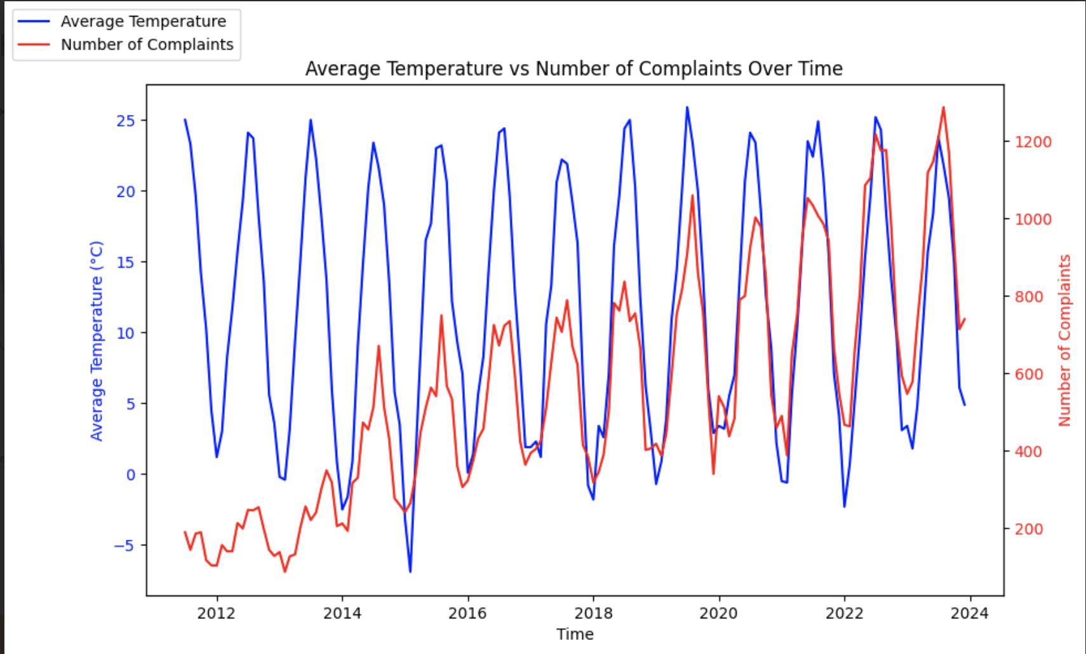

We found that the number of requests is strongly positively correlated to higher temperatures and seasonal trends. However, the same correlation was not obvious in other weather variables we looked at, such as the amount of snow, rain, and extreme weather:

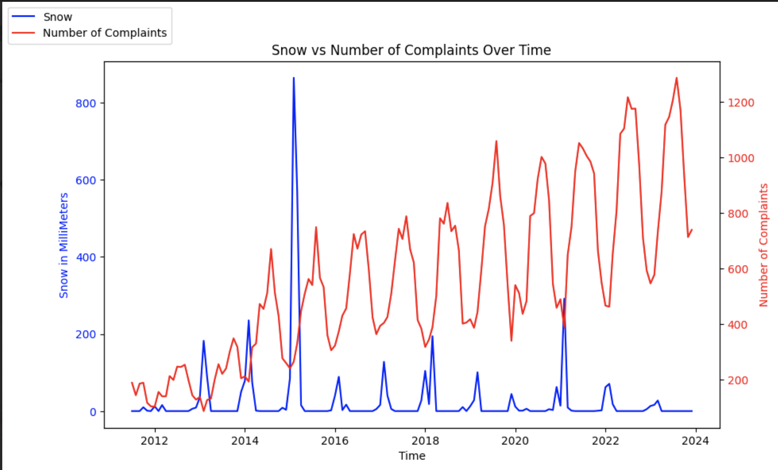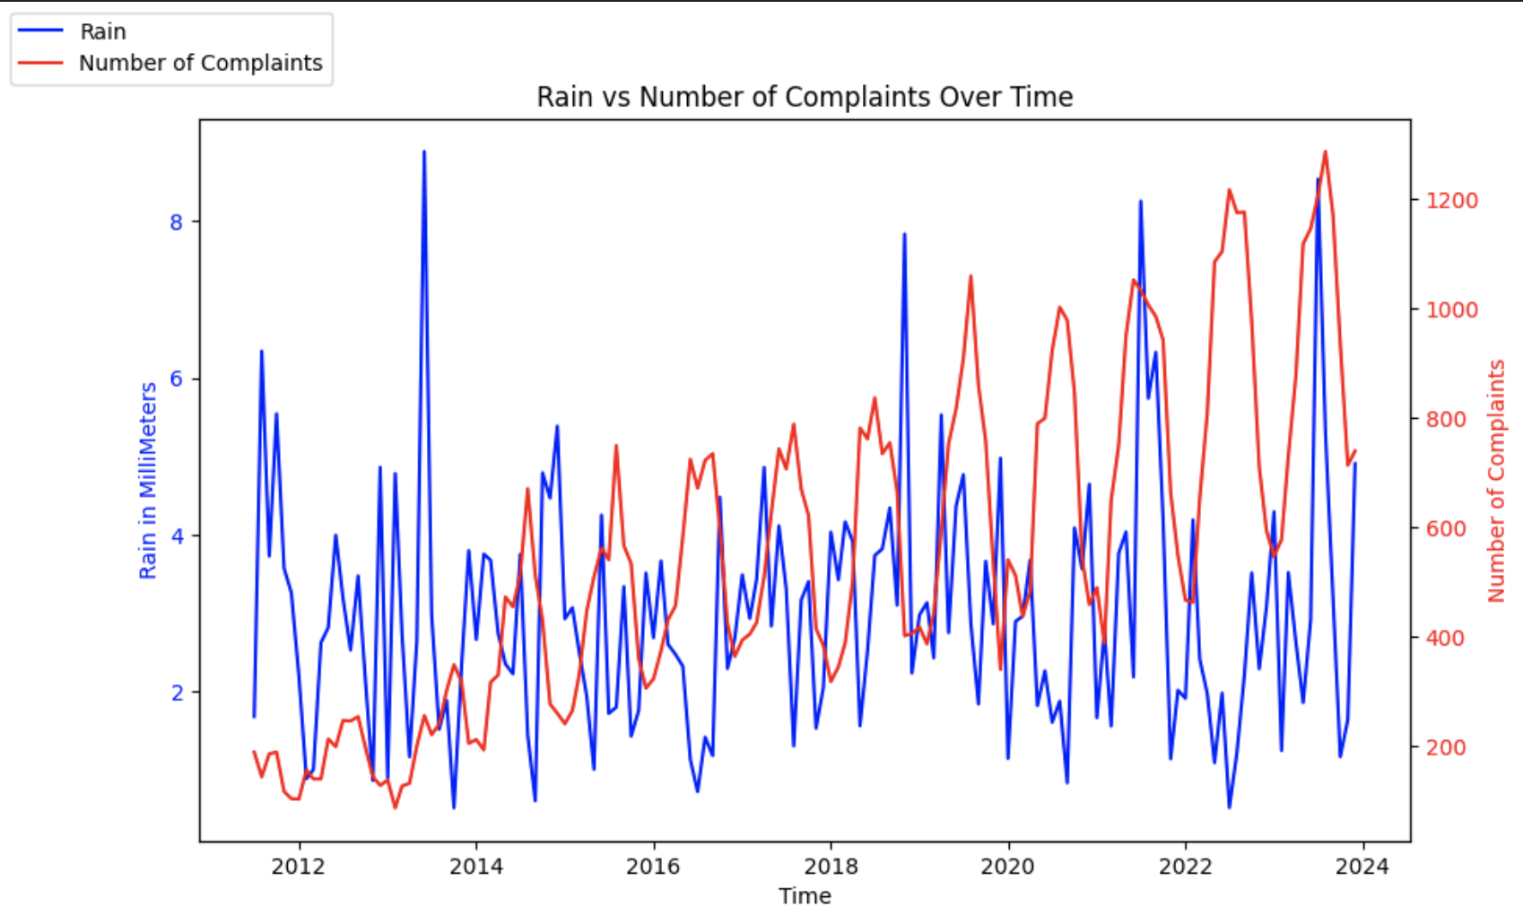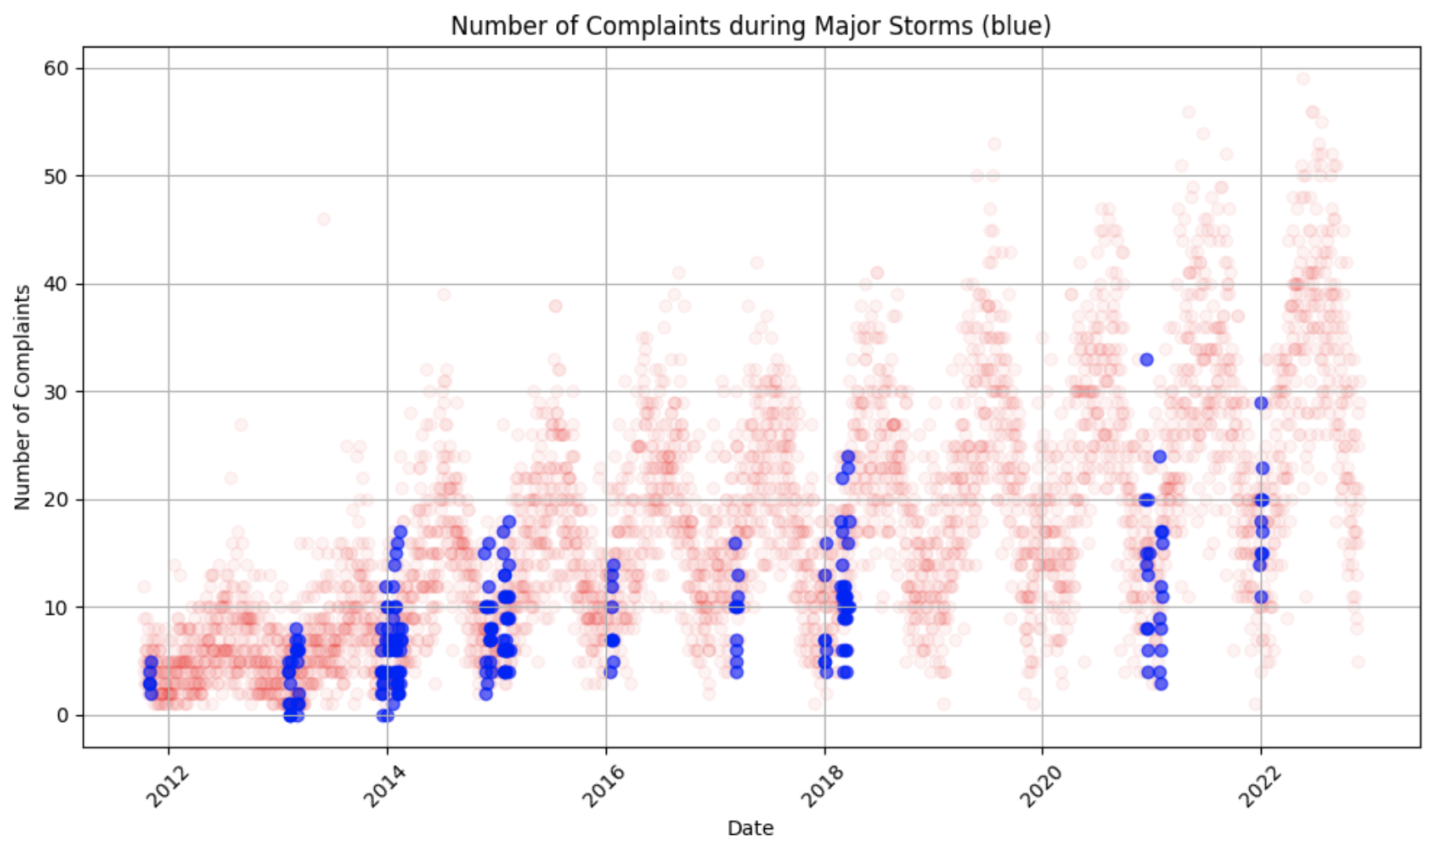

The amount of snow, rain, and extreme weather did not seem to affect the amount of animal complaints. The lack of correlation found could be due to more data being required, as there is not a lot of data for intense storms (above category 1) or differing types of extreme weather, such as earthquakes. A more defined relationship between rain, snow, and extreme weather could be the focus of further exploration of the dataset.

## Future Scope

It is important to continue monitoring the trends identified in this study to determine if they persist or evolve. One area of focus for future research is to closely monitor the impact of extreme weather events, such as hurricanes and snowstorms, on animal-related complaints. The data provided only had the lowest level hurricanes, making it hard to determine if there is a correlation between actual extreme weather and report amounts. By understanding how weather patterns affect animal-related issues, the city can better prepare and allocate resources to address them effectively.

Additionally, tracking changes in population density in each zip code could help contextualize trends in animal-related complaints. As Boston's population grows and shifts, so too may the patterns of animal-related concerns within the city. By keeping a close eye on population changes, we can adjust our strategies and interventions accordingly, like which zip codes need more manpower or which zip codes need more advertising of the 311 system in general.

It is also important to assess and update the methods for surveying and reporting animal-related complaints, such as advertisements. Monitoring the number of requests before or after advertisements can serve as a metric to gauge the effectiveness of these improvements.

Furthermore, addressing errors and inconsistencies in the recorded data is essential for maintaining the integrity of future analyses. Cleaning historical data to rectify issues such as duplicate rows and discrepancies in time data (open or on time without a target date or completion date) will help improve the accuracy of our findings and ensure that any insights drawn from the data are reliable.

By incorporating these considerations into future research efforts, Boston can continue to refine its understanding of animal-related complaints and develop targeted interventions to address them effectively. This ongoing analysis will ultimately support the city in enhancing its responsiveness to the needs and concerns of its residents regarding animal welfare and safety.

## Individual Contribution

Mariano served as the Team Leader, actively engaging in client meetings, delivering slideshow reports, and communicating with the team representative, Arya. He combined and parsed CSVs to generate a comprehensive dataset for project continuity. Mariano helped edit and analyze the Mid Semester Report, crafting zip code graphs to depict request patterns and trends, including the distribution of various animal types across different zip codes.

Eric initiated the data analysis, brainstorming unaddressed questions such as late requests and delving into broader 311 data trends. He visualized data, examining yearly variations, Boston's population, and temporal factors like month and season. Additionally, Eric delved into specific zip code details, including population density for areas with high request volumes. He also organized scrum reports and assigned weekly tasks. Eric contributed to editing and analyzing Early Insights and the Mid Semester Report, offering insightful edits crafting the project's future scope, and editing the final report. He also helped create the project's README.

Raghu undertook data preprocessing tasks, aided in creating heat map graphs and resolved issues related to data limitations. His contributions to editing and analyzing the Mid Semester Report were substantial, ensuring accuracy and clarity in the presentation of findings, and developing the initial heat maps to analyze the location data. Raghu also helped analyze weather in the extension project, using NOAA data, to see whether snow, rain, and temperature data affected animal reports across the city.

Sam helped with git management and made substantial contributions to the Final Report, combining information from previous presentations and contextualizing it within the project's broader scope. He also created diverse graphs comparing the number of reports for different years. He also made the heat map zip code gifs. Additionally, he helped with GMM clustering to analyze zip code patterns.

Shangyuan assisted in creating the project's README file and supported others. He helped fix citations and do grammar checks in the report to make it as formal and precise as possible.

## 

## Works Cited

Analyze Boston. “311 Service Requests.” *311 Service Requests*, Department of Innovation and Technology, 2011, data.boston.gov/dataset/311-service-requests.

Macrotrends LLC. “Boston Metro Area Population 1950-2024.” *Macrotrends.net*, 2024, www.macrotrends.net/global-metrics/cities/22939/boston/population.

O'Brien, Dan, Hangen, Forrest, and Ristea, Alina. *311 Requests*. 2016, Harvard Dataverse, doi:10.7910/DVN/CVKM87.

United States Zip Codes. “U.S. ZIP Codes: Free ZIP Code Map and Zip Code Lookup.” *UnitedStatesZipCodes*, 2010, www.unitedstateszipcodes.org/.

Wikipedia Contributors. “List of New England Hurricanes.” *Wikipedia*, 9 Apr. 2023, en.wikipedia.org/wiki/List_of_New_England_hurricanes.

---. “List of Northeast Snowfall Impact Scale Winter Storms.” *Wikipedia*, Wikimedia Foundation, 20 Nov. 2019, en.wikipedia.org/wiki/List_of_Northeast_Snowfall_Impact_Scale_winter_storms.